The Cotswold Savoyards

The Mikado Tues 20th - Sat 24th May 2014
By W.S.Gilbert and Arthur Sullivan

Dear Friend,
We hope you enjoyed “Ruddygore” at the Everyman Theatre in June and “Jekyll and Hyde” at the Playhouse in November. In May 2014, we are excited to present the Cotswold Savoyards’ one hundredth production, “The Mikado”. This milestone could not have been reached without the generous and enthusiastic support of the Friends of Cotswold Savoyards and we would be delighted if you were to join us again in May as we celebrate “one hundred not out”! We are able to offer you the opportunity of reserving your tickets in advance of them going on sale to the general public at the Everyman box office, so you can have the best seats! If you can indicate an area on the plan overleaf where you would like to sit, I will allocate the best seats for you (don’t forget to specify stalls/circle etc.). The earliest replies get the best seats as we allocate strictly in the order replies are received. Ticket prices will remain at 2012 levels. A booking fee of £1 is charged by The Everyman on all ticket sales which we have included in the prices shown below.

We look forward to seeing you in the town of Titipu in May!

Paul Chesworth, Cotswold Savoyards Ticket Secretary.

“What do a love affair between a Wandering Minstrel and a Ward of the Public Executioner, an older woman out for revenge, a haughty ‘know all’, and the Emperor of Japan have in common? You might well ask, but then this is the Topsy Turvey world of Gilbert and Sullivan’s ‘The Mikado’.
Written in 1885, The Mikado is packed with toe tapping tunes that were the ‘pop’ songs of their day, and combined with wonderfully witty dialogue, this is a show which provides good fun and all round entertainment.
Chosen by the Cotswold Savoyards to mark their 100th production and given a more modern twist without losing any of the original Savoy splendour, this is one for all the family to enjoy.”

Margaret Craven, Stage Director.

For all ticket prices and details of discounts, please see the separate enclosed booking form.

In order to make things simpler we are again using the same pricing bands as the Everyman Theatre use in their brochure. On the booking form, we have tried to replicate this as best we can but if you wish to see a colour version then see either the current Everyman Brochure or visit their website: www.everymantheatre.org.uk/box_office/seating_plan.html
If you would like to book tickets, please complete the enclosed form and return with payment and S.A.E. by Friday 7th February 2014. Please note, we will send tickets out to you as soon as they are received from the Everyman Theatre and this may mean a delay of a few weeks after February 7th.
If you have any queries, please contact me either at the address given on the enclosed form or by e-mail at ticket.secretary@cotswoldsavoyards.org
I look forward to hearing from you.
Paul Chesworth
-------------------------------------- Keep for your records ---------------------------------------------------------------------
Paul Chesworth, Ticket Secretary, Cotswold Savoyards,
16 Southern Road, Leckhampton, Cheltenham, GL53 9AW - 01242 352512
ticket.secretary@cotswoldsavoyards.org

THE COTSWOLD SAVOYARDS

FRIENDS’ BOOKING FORM
Received Form No:
The Mikado

EVERYMAN THEATRE, CHELTENHAM TUESDAY 20th – SATURDAY 24th May 2014

Evenings: 7.45 pm Matinee: Saturday 2.00 pm

Name: ___________________________________________________ Tel. No: __________________

Address: ___________________________________________________________________________

_________________________________________________________ Postcode: _________________
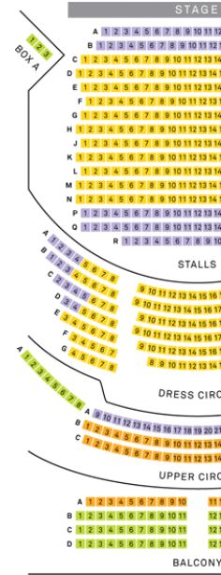
Price Band 2
Please indicate number of seats required under
each date and price band
(please note any special requests on the seating plan and I
will do my best to accommodate them on a first come basis)
Price Band | 1 | 2 | 3 | 4 |  | Please leave blank
Tuesday 20th May 7.45pm | £17 | £17 | £15 | £13
Wednesday 21st May 7.45pm | £19 | £19 | £17 | £15
Thursday 22nd  May 7.45pm | £19 | £19 | £17 | £15
Friday 23rd  May 7.45pm | £19 | £19 | £17 | £15
Saturday 24th May 2.00pm | £19 | £19 | £17 | £15
Saturday 24th May 7.45pm | £19 | £19 | £17 | £15
Under 18’s/ students = £10 for any performance
Group of 10 or more for same performance (Wed – Sat)
= £2 discount per ticket

Total Ticket Cost £
Other discounts £
Amount Enclosed £

Cheques payable to ‘The Cotswold Savoyards’
We regret that tickets cannot be exchanged or returned after issue

Please return form with full payment and S.A.E. by
7th February 2014 to:
Paul Chesworth The Cotswold Savoyards’ Ticket Secretary, 16 Southern Road, Leckhampton, Cheltenham GL53 9AW

Price Band 4

Price Band 4
Price Band 1
Price Band 4
Note: For some performances seats on the far sides of the dress circle may experience a restricted view.
For a colour chart please visit: www.everymantheatre.org.uk/box_office/seating_plan.html
Price Band 3 3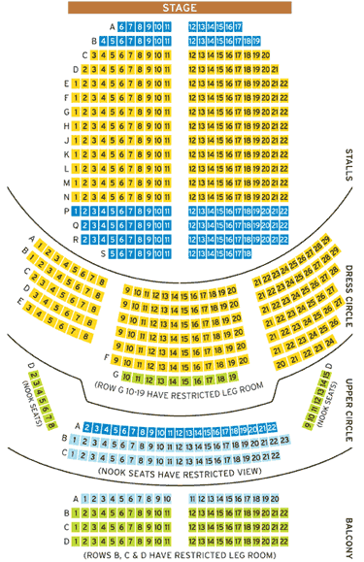
Price Band 2

